**Date:** 02/08/2016

**Roll No. and Name:** 14BCE154 Chauhan Prasiddh J.

14BCE151 Baldaniya Rushabhkumar H.

**Course Code and Name:** Open Source Development Lab (CE703)

**Practical No.:** 1 (Python)

**AIM:** To develop a mini project in python to illustrate the implementation of MySQL Database connectivity

**Methodology followed (Code):**

#!/usr/bin/python

import MySQLdb

import os

os.system('cls')

print("-----------------------------welcome To Database Viewer----------------------------------------\n")

try:

db_name = raw_input("\t\tEnter Database Name:")

db = MySQLdb.connect("localhost","root","",db_name)

flag = 1

while flag:

cursor = db.cursor()

os.system('cls')

cursor.execute("show tables")

results = cursor.fetchall()

print("Tables in Database : \n-------------")

for row in results:

table_name = row[0]

# Now print fetched result

print "%s\t" % \

(table_name)

print("-------------")

table_name=raw_input("Please Select Table To show:")

os.system('cls')

print ("------------------"+ table_name+" Table Enteries-------------------\n============================================================")

sql = "SELECT * FROM "+table_name

cursor.execute(sql)

results = cursor.fetchall()

widths = []

columns = []

tavnit = '|'

separator = '+'

for cd in cursor.description:

widths.append(max(cd[2], len(cd[0])))

columns.append(cd[0])

for w in widths:

tavnit += " %-"+"%ss |" % (w,)

separator += '-'*w + '--+'

print(separator)

print(tavnit % tuple(columns))

print(separator)

for row in results:

print(tavnit % row)

print(separator)

columns = cursor.description

result = []

for value in cursor.fetchall():

tmp = {}

for (index,column) in enumerate(value):

tmp[columns[index][0]] = column

result.append(tmp)

flag = input("Press 1 key to continue. | press 2 key to close. \n\n\t")

if flag == 1:

os.system('cls')

else:

flag = 0

print "Database Viewer is close successfully..!!"

db.close()

except MySQLdb.Error as e:

print(e)

except :

print("Unknown error occurred")

**Sample Input:**

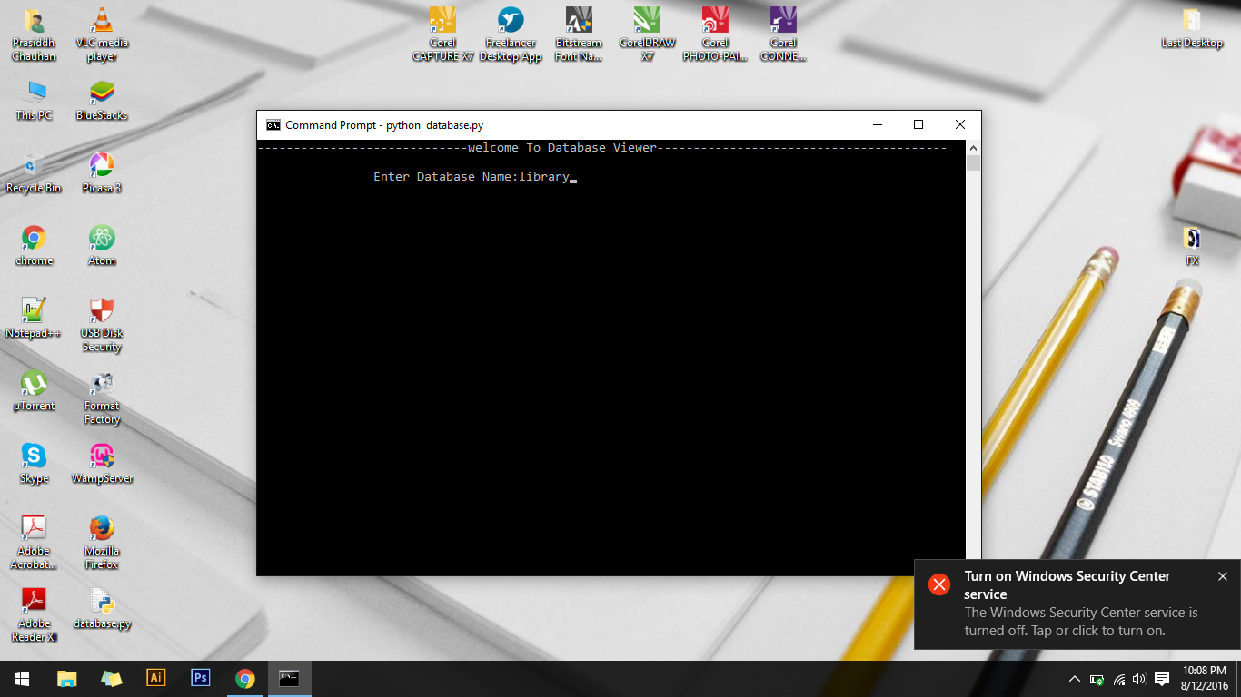

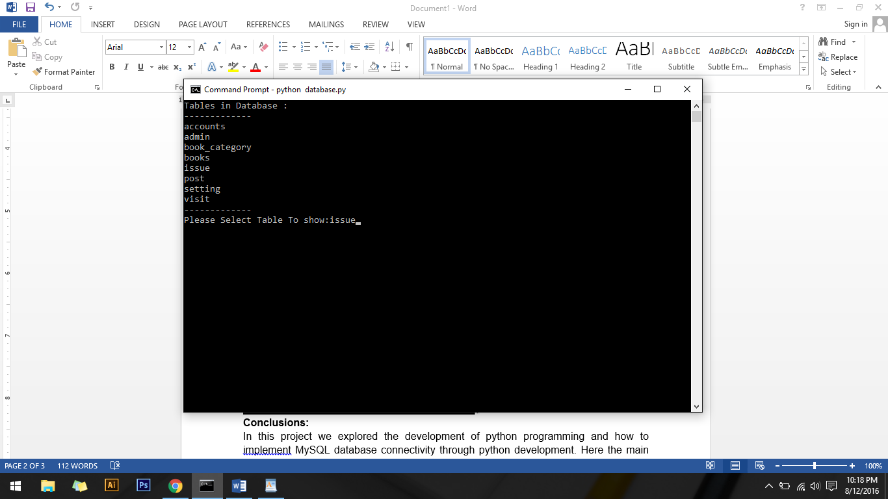

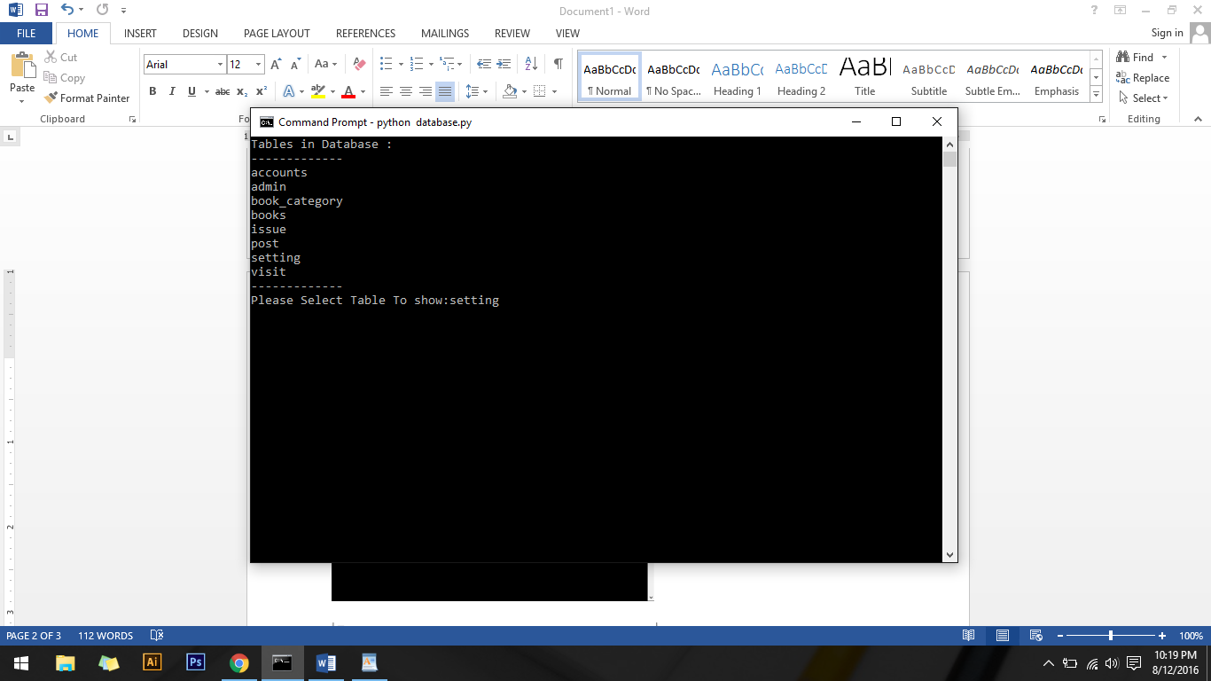

**Sample Output:**

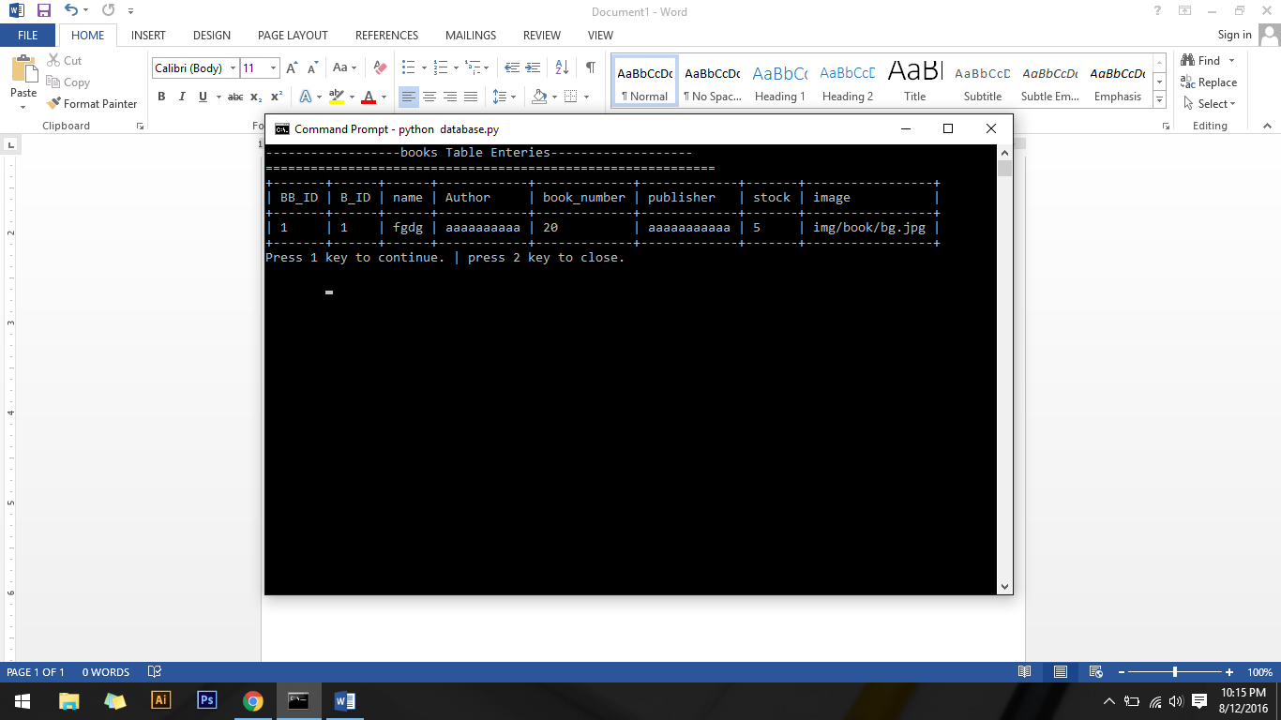

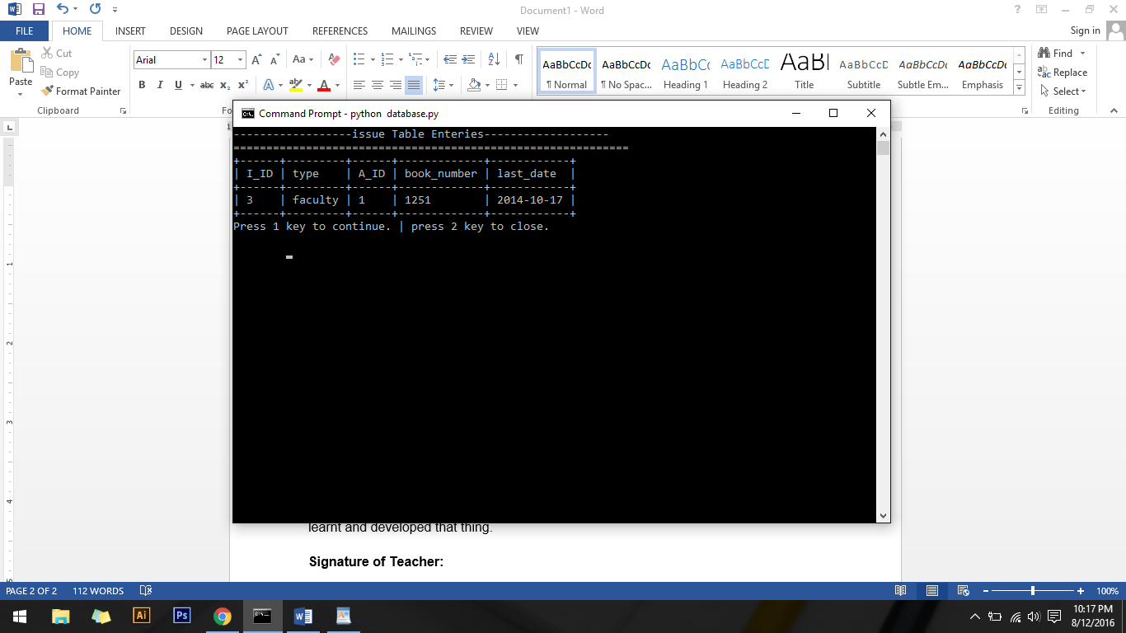

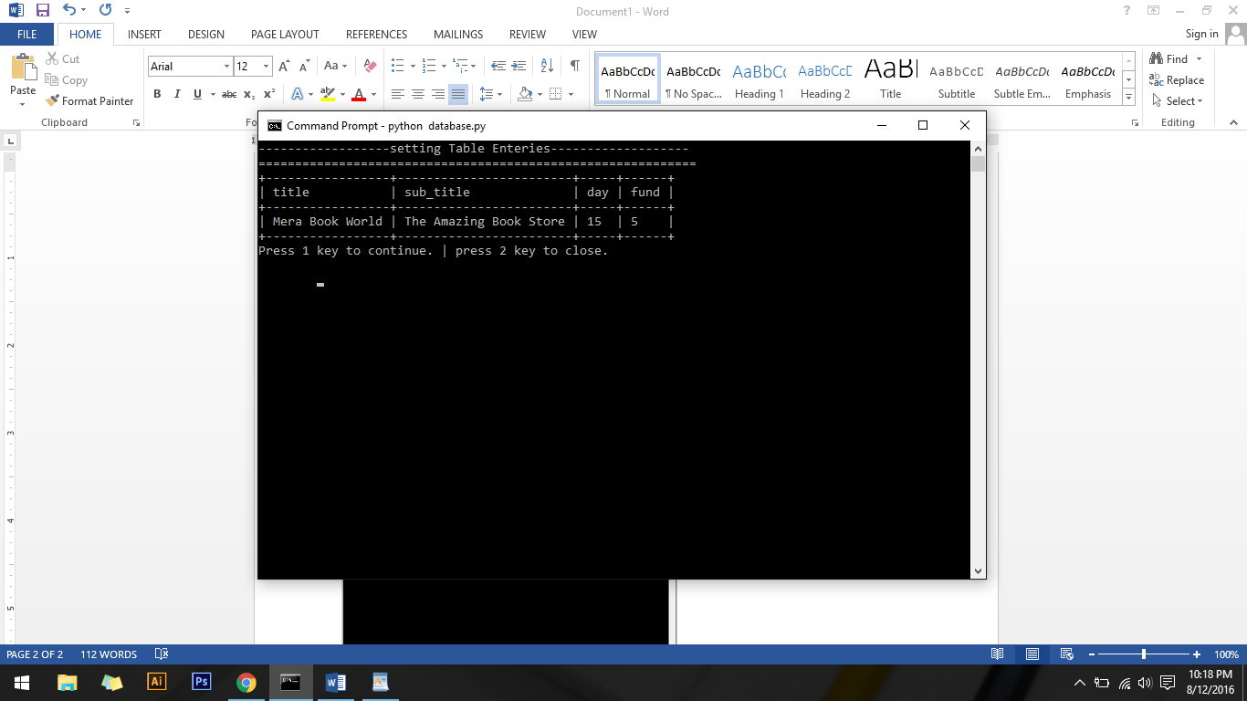

**Conclusions:**

In this project we explored the development of python programming and how to implement MySQL database connectivity through python development. Here the main part is to use the OS cmd command through importing the OS library and integration of both the things in python development environment which is new thing for us and we learnt and developed that thing.

**Signature of Teacher:**